Booking Form Request

Thank you for your interest in our Holistic Fairs!

Our aim is to offer customers who visit our Holistic Fairs unique and high-vibrational services and products. Anything new, unusual, and exciting is very welcome!

So, if you want to hire a stand for the event, please read these T&C’s, complete your details, sign the form below and return it to jovi@love2meditate.com as soon as possible.

Once we, the organisers, decide you are perfect for our event, we will send you a confirmation of your booking with an invoice. Only once the payment is received will your booking be guaranteed. We request that all invoices are paid within two days of receipt.

We look forward to working with you and together supporting our customers.

With our highest vibrational love and support

Jovi and Teresa
Holistic Fair Organisers
Holistic Fair details

Venue: Alton Community Centre, Amery Street, Alton, GU34 1HN

Date and time: 11th September 2021, 10am to 4pm

Cost: £35 / stand (if you want to do a talk/workshop and don’t have a stand, the cost will be £10. If you have a stand and are wanting to do a talk, there will be no extra charge).

Parking: Vicarage Hill Lane car park, 18-22 High Street, Alton, GU34 1BN

Entrance: Alton Community Centre can be accessed via the car park.

Setting up: From 9.00am (no-one will be allowed in before this time. Please aim to set up your stand for opening time.

Table deco: You will be provided with a 6ft table. Please bring a large sheet to cover your table so you can hide your stock, boxes, packaging underneath, out of sight. You are welcome to bring marketing free-standing roller banners. We believe you can attach posters to the wall using blue tack, but we will need to confirm this first.

Setting down: Setting down will start from 4.00pm and you will be allowed 1 hour. Please refrain from packing anything away earlier as this puts emotional pressure on customers to rush through. We want customers to have enough time to make the right decisions for themselves.

Rubbish: There are some large bins that you can use to get rid of your empty boxes.

Refreshments: There is a café within the community centre.

Talks: The talks will be held in the café.

Terms and Conditions
- Once you receive an invoice, it is your responsibility to pay the non-refundable, non-transferable full amount for the event within two days of receipt. This will guarantee your booking. If the organisers do not receive your payment within two days, your stand may be given to someone else on the waiting list. Once payment has been made, send an email to jovi@love2meditate.com to confirm payment has been made so it can be allocated correctly.
- If the venue cancel the event due to covid-19 or any other situation beyond their control, the organisers will cancel the booking and where possible, reimburse the cost of the stand.
- If you cancel your attendance, once it has been agreed, due to any circumstance, you will not be refunded any costs. However, we do understand that this may happen so where possible, if we are able to get a replacement to hire your stand, we will offer a refund.
- You shall not use the property for anything but the agreed permitted use. If anything is observed that is not in the peaceful and spiritual culture of the fair, the organisers have every right to request that you leave, without providing a refund and thereafter holding you responsible for any consequential liability damages or loss.
- Please comply fully with all and any health and safety regulations as laid out by the venue. The organisers are not liable for any injuries to you or the customers around your stand. This means, that you must ensure there are no trip hazard risks around your stand. Ensure all your electrical equipment has been PAT tested. It is also your responsibility to point out to others of any health and safety issues you become aware of.
- The organisers will not accept any responsibility for loss or damage of personal possessions or valuables. You are ultimately responsible for your own property.
- You are solely responsible for any damage caused by you to the venue.
Your details
Please print details clearly
Date of Holistic Fair | 11th September 2021
Venue | Alton Community Centre
Your name
Company name (if different)
Contact details | Email address
 | Telephone no.
 | FB page
 | Instagram page
 | Website
What is your business tag line?
What is your USP? We would like to use it to advertise you and the event.
Which service are you providing (highlight/circle and provide further details below) | Shop | Healers |  | Readers |  | Workshops  Half an hour talks, experience, workshops
Further details  Please provide clear details on what you are offering | What are you selling? | What kind of healing will you be doing? |  | What kind of readings will you be offering? |  | What talk will you be doing?
Do you require a plug socket? If yes, what do you need it for?
Have you attached your Public Liability insurance? | Yes |  | No |  | I don’t have one
A 6ft table will be provided and two chairs. If anything else is required, please state here.
Any other information we need to know?

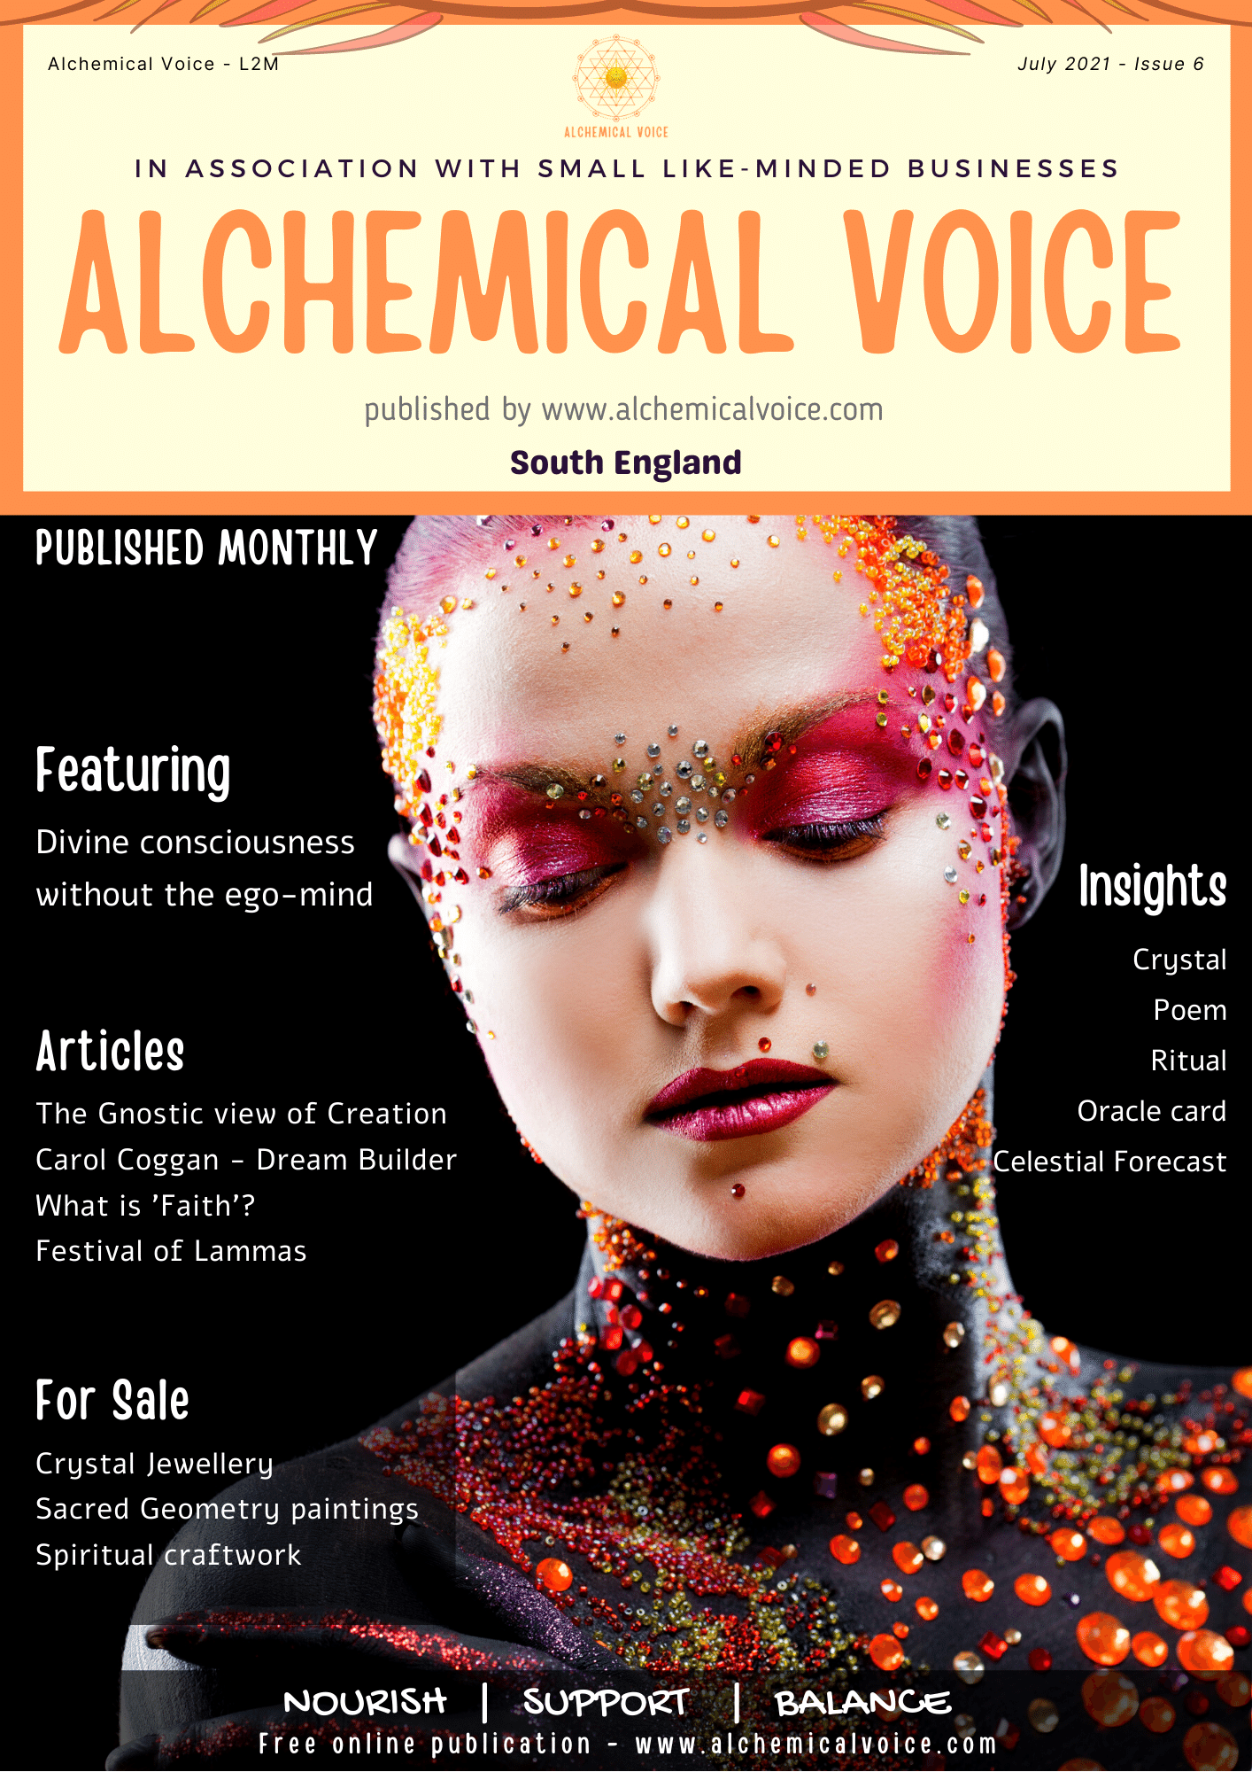
We produce an online magazine called Alchemical Voice, supporting small holistic businesses.

You can access all publications online www.alchemicalvoice.com. We send an email out to advise you when we release the next edition. If you want to be part of this – state yes below.

Visit ‘Advertise with us’ page if you want to advertise with us.

By signing this form, you agree to the terms and conditions as laid out above.

Receive our newsletters? If you don’t specify another email address, we will use the one stated in ‘Your details’ section. Note that if you are working in fairs, you will automatically be added to the newsletters. Yes / No

Signature
Date

Return your completed form request to jovi@love2meditate.com

