Booking Form Request

Thank you for your interest in our Holistic Fairs!

Our aim is to offer customers who visit our Holistic Fairs unique and high-vibrational services and products. Anything new, unusual, and exciting is very welcome!

So, if you want to hire a stand for the event, please read these T&C’s, complete your details, sign the form below and return it to jovi@love2meditate.com as soon as possible.

When you return the booking form, please arrange the payment to be made to
Bank: NatWest
Name: Teresa-Rae Hemmings
Account No: 48390615
Sort Code: 60-01-13
Ref: Your name/Dec21

Only once the payment is received will your booking be guaranteed.

We look forward to working with you and together supporting our customers.

With our highest vibrational love and support
Jovi and Teresa
Holistic Fair Organisers
Holistic Fair details

Venue: Alton Community Centre, Amery Street, Alton, GU34 1HN

Date and time: 5th December 2021, 10.30am to 4pm

Cost: £45 / stand (if you want to do a talk/workshop and don’t have a stand, the cost will be £20. If you have a stand and are wanting to do a talk, there will be no extra charge).

Parking: Vicarage Hill Lane car park, 18-22 High Street, Alton, GU34 1BN

Entrance: Alton Community Centre can be accessed via the car park.

Setting up: From 9.00am (no-one will be allowed in before this time. Please aim to be ready for opening time.

Table deco: You will be provided with a 6ft table. Please bring a large sheet to cover your table so you can hide your stock, boxes, packaging underneath, out of sight. You are welcome to bring marketing free-standing roller banners. We believe you can attach posters to the wall using blue tack, but we will need to confirm this first.

Setting down: Setting down will start from 4.00pm and you will be allowed 1 hour. Please refrain from packing anything away earlier as this puts emotional pressure on customers to rush through. We want customers to have enough time to make the right decisions for themselves.

Rubbish: There are some large bins that you can use to get rid of your empty boxes.

Refreshments: There is a café within the community centre.

Terms and Conditions
- Once you return your booking form, please make your payment at the same time (payment is non-refundable and non-transferable). The payment guarantees your booking. Send an email to jovi@love2meditate.com so your payment will be allocated correctly.
- If the venue cancels the event due to covid-19 or any other situation beyond their control, the organisers will cancel the booking and where possible, reimburse the cost of the stand.
- If you cancel your attendance, once it has been agreed and paid, due to any circumstance, you will not be refunded any costs. However, we do understand that this may happen so, where possible, if we are able to get a replacement to hire your stand, we will provide you with a refund.
- You shall not use the property for anything but the agreed permitted use. If anything is observed that is not in the peaceful and spiritual culture of the fair, the organisers have every right to request that you leave, without providing a refund and thereafter holding you responsible for any consequential liability damages or loss.
- Please comply fully with all and any health and safety regulations as laid out by the venue. The organisers are not liable for any injuries to you or the customers around your stand. This means, that you must ensure there are no trip hazard risks around your stand. Ensure all your electrical equipment has been PAT tested. It is also your responsibility to point out to others of any health and safety issues you become aware of.
- The organisers will not accept any responsibility for loss or damage of personal possessions or valuables. You are ultimately responsible for your own property.
- You are solely responsible for any damage caused by you to the venue.
Your details
Please print details clearly
Date of Holistic Fair | Sunday 5th December 2021
Venue | Alton Community Centre
Your name
Company name (if different)
Contact details | Email address
 | Telephone no.
 | FB page
 | Instagram page
 | Website
Please connect with our social media pages.
We are organising our own Holistic Fair Organisers page, but until we get that set up, the event will be set up on Shamanic Joy UK page.
Fb: @shamanicjoyuk, @love2meditate, @alchemicalvoice
Instagram: love_2_meditate
How do you want us to advertise what you are offering?
Which service are you providing (highlight/circle and provide further details below) | Shop | Healers | Readers | Workshops  Half an hour talks, experience, workshops
Further details  Please provide clear details on what you are offering | What are you selling? | What kind of healing will you be doing? | What kind of readings will you be offering? | What talk will you be doing?
Do you require a plug socket? If yes, what do you need it for?
Healers – please bring your Public Liability insurance with
A 6ft table will be provided and two chairs. If anything else is required, please state here.
Any other information we need to know?

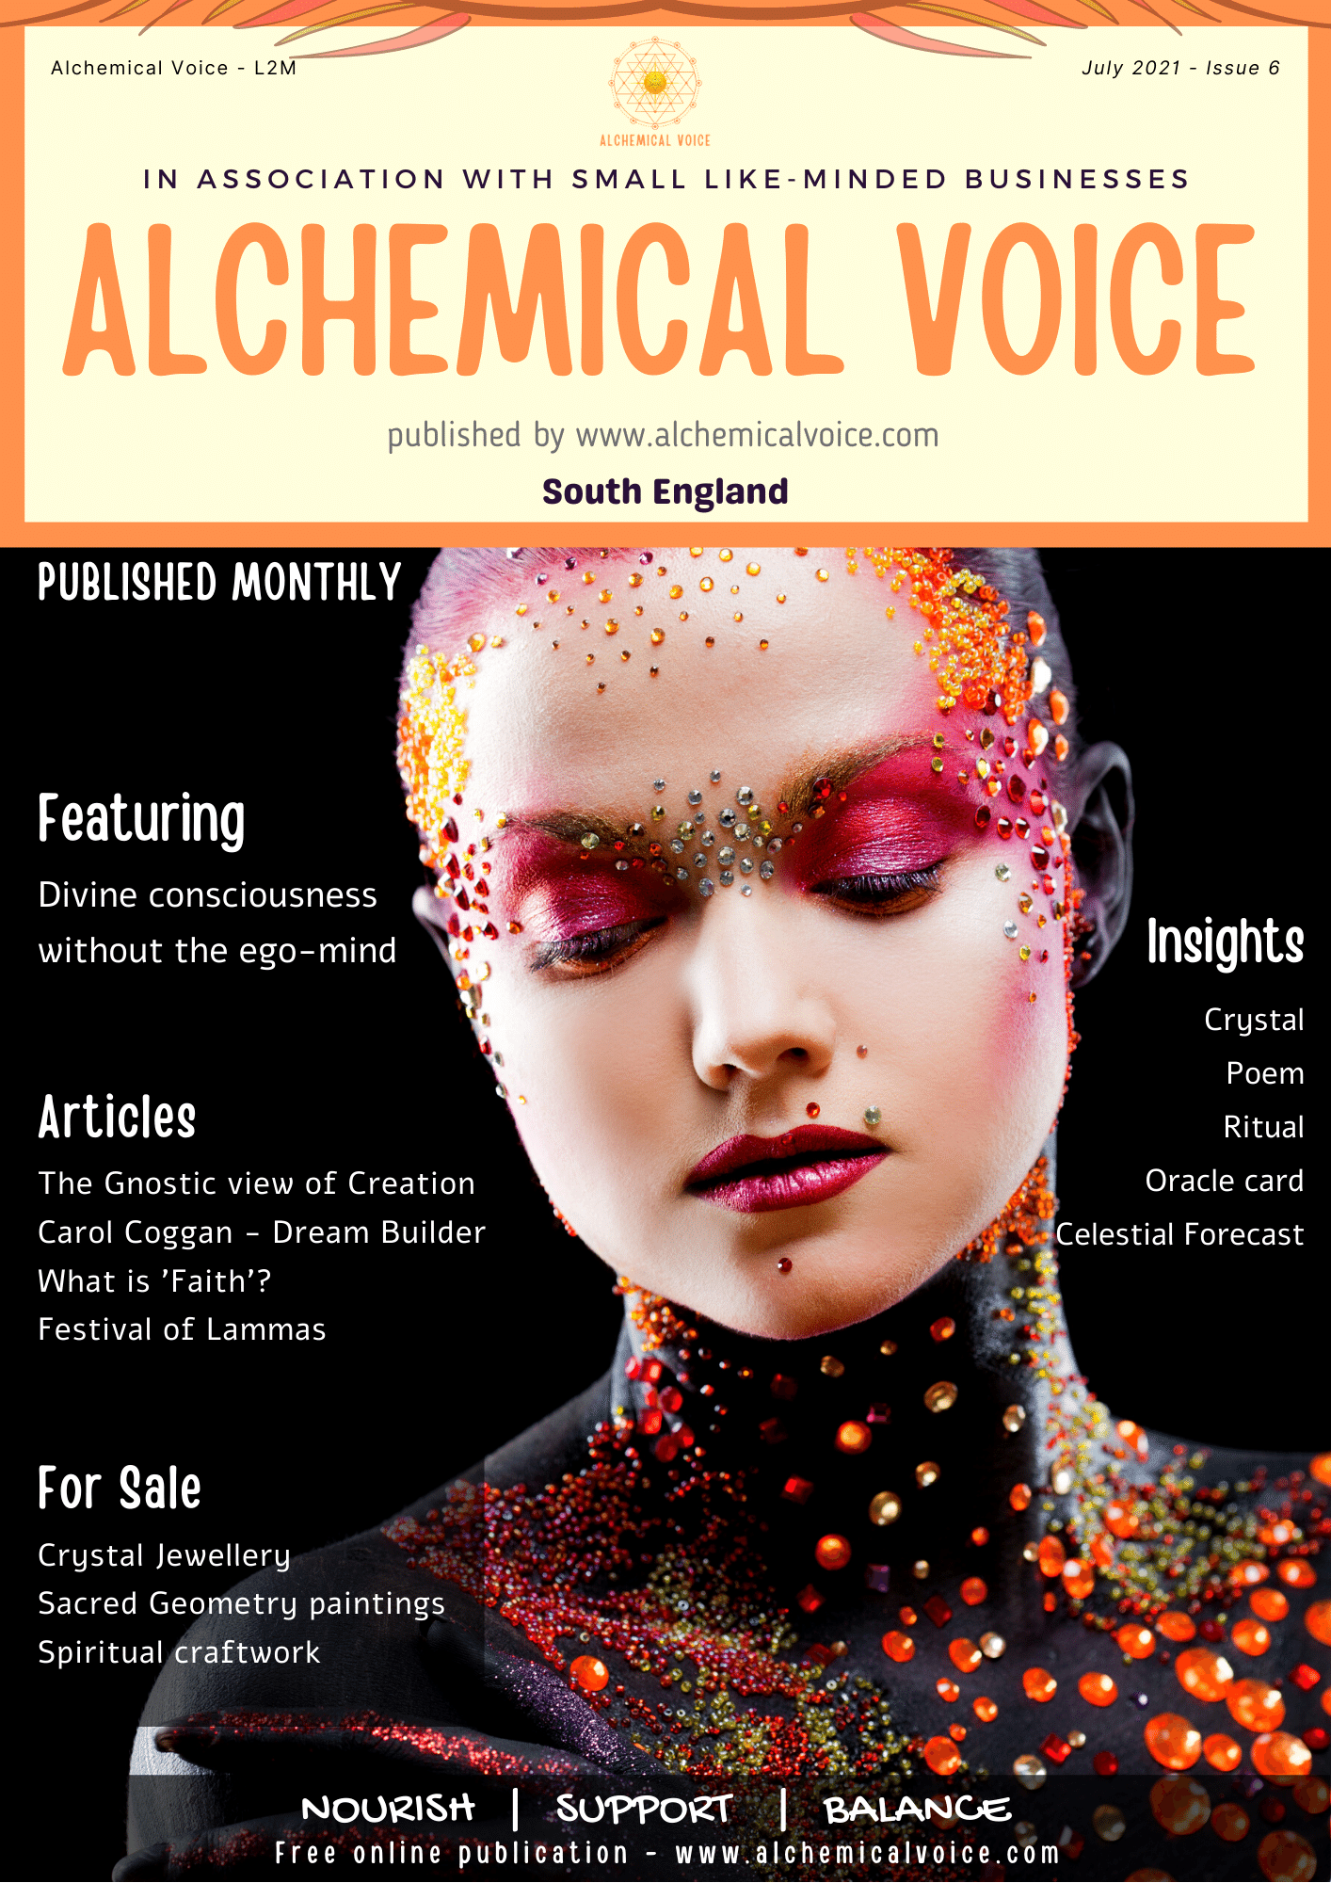
We produce an online magazine called Alchemical Voice, supporting small holistic businesses.

You can access all publications online www.alchemicalvoice.com. We send an email out to advise you when we release the next edition. If you want to be part of this – state yes below.

Visit ‘Advertise with us’ page if you want to advertise with us.

By signing this form, you agree to the terms and conditions as laid out above.

Want to receive our newsletters? If you don’t specify another email address, we will use the one stated in ‘Your details’ section. Note that if you are working in fairs, you will automatically be added to the newsletters. Yes / No

Signature
Date

Return your completed form request to jovi@love2meditate.com

