My Personal Journey

Write your name here
  - and the Date

Believe in your Power | Jovi Hoonjan | Love 2 Meditate

Contents
1 - Introduction 2
2 – Power Animal Support 3
3 - Making Powerful Bonds 6
4 – The Perfect Power 9
4 - Dance with Me 12
6 – The Shield 15
7 - The Evaluation 18

1 - Introduction

Please use this Journal to record all your insights and discoveries. Type in the boxes, they will automatically expand.
If you prefer to work with a printed copy, you will first need to expand the text boxes or remove them completely, creating space for you to write underneath the questions.

Feel free to listen to any of the meditations or repeat the exercises more than once – the more you do them, the stronger the impact you will have.

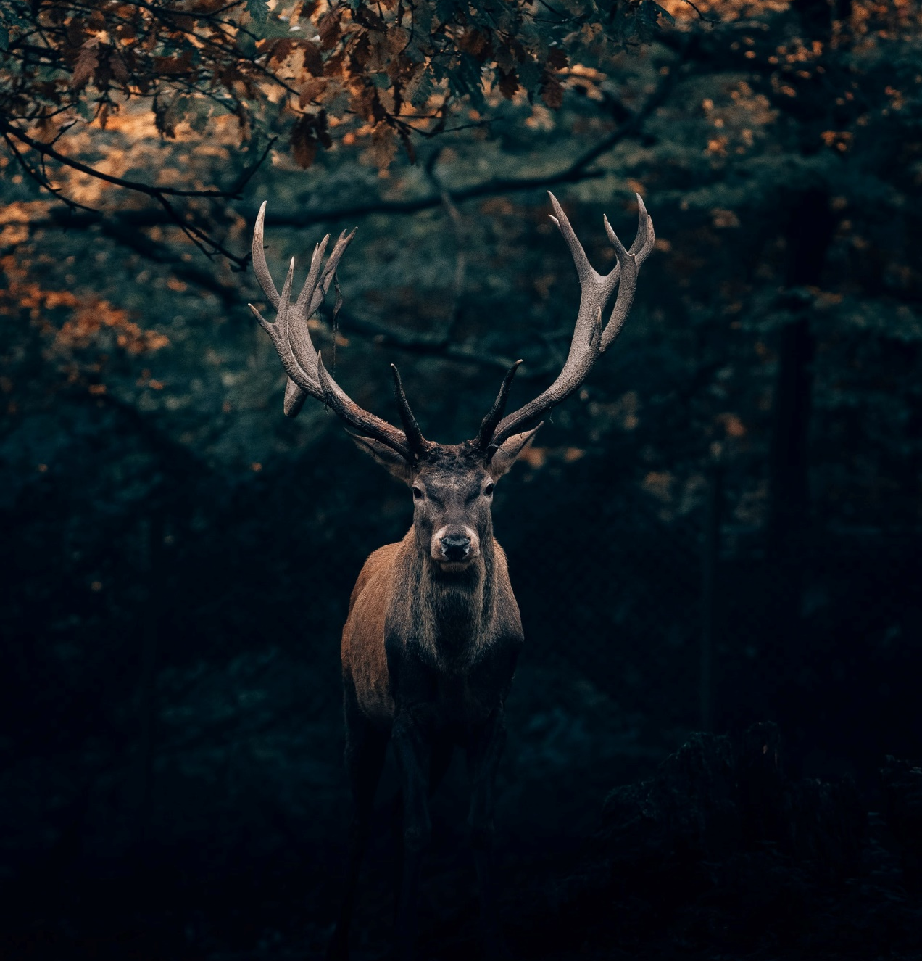
2 – Power Animal Support

Date | What time of day was the meditation done? | What happened and what messages did you receive (feelings, sensations, relaxed, energized, sounds, images, inner knowing, sensations, warm, cold, tingling…)

Who was your Power animal?
If you feel you didn’t connect with a power animal, listen to the meditation again. Normally you will see parts of the animal.

What support elements does your power animal bring to you?

What dreams did you have? Come back tomorrow to add your dreams here, did you sleep well?

Any further comments or insights?

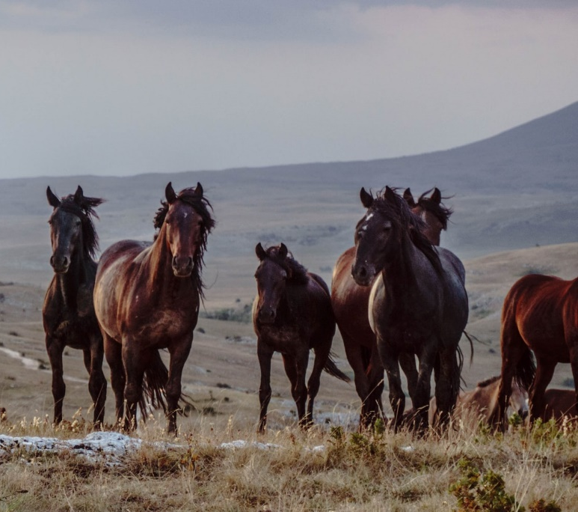
3 - Making Powerful Bonds

Date | What time of day was the meditation done? | What happened and what messages did you receive (feelings, sensations, relaxed, energized, sounds, images, inner knowing, sensations, warm, cold, tingling…)

What were your overall thoughts on performing the ritual?

What insights came up for you?

What dreams did you have? Come back tomorrow to add your dreams here.

Any further comments or insights?

Rituals are amazing exercises to perform, we suggest you experiment and do more. You could create your very own ritual or you could change ours a little to suit you.
You could select different animals that you are personally drawn to and add them.

4 – The Perfect Power

Date | What time of day was the meditation done? | What happened and what messages did you receive (feelings, sensations, relaxed, energized, sounds, images, inner knowing, sensations, warm, cold, tingling…)

Before you listen to the Powerful Warrior meditation journey
How do you feel you are progressing so far?

Look back at the notes you have made so far. Do you see any repetitions in your comments? Do you feel you have made lots of similar discoveries? See if you are able to analyze them yourself. The more you can independently and confidently trust in your own interpretation, the stronger your intuition will be.

After listening to the meditation journey
What questions have arisen for you?

What dreams did you have? Come back tomorrow to add your dreams here.

Any further comments or insights?

4 - Dance with Me

Date | What time of day was the meditation done? | What happened and what messages did you receive (feelings, sensations, relaxed, energized, sounds, images, inner knowing, sensations, warm, cold, tingling…)

Is this a new experience for you? What music did you play?

How easy was it for you to relax and surrender yourself to the dance? Were you able to get the privacy?

How did you feel?

What questions have arisen for you?

What dreams did you have? Come back tomorrow to add your dreams here.

Any further comments or insights?

6 – The Shield

Date | What time of day was the meditation done? | What happened and what messages did you receive (feelings, sensations, relaxed, energized, sounds, images, inner knowing, sensations, warm, cold, tingling…)

Did you feel anything throughout the meditation journey?

What questions have arisen for you?

What dreams did you have? Come back tomorrow to add your dreams here.

Any further comments or insights?

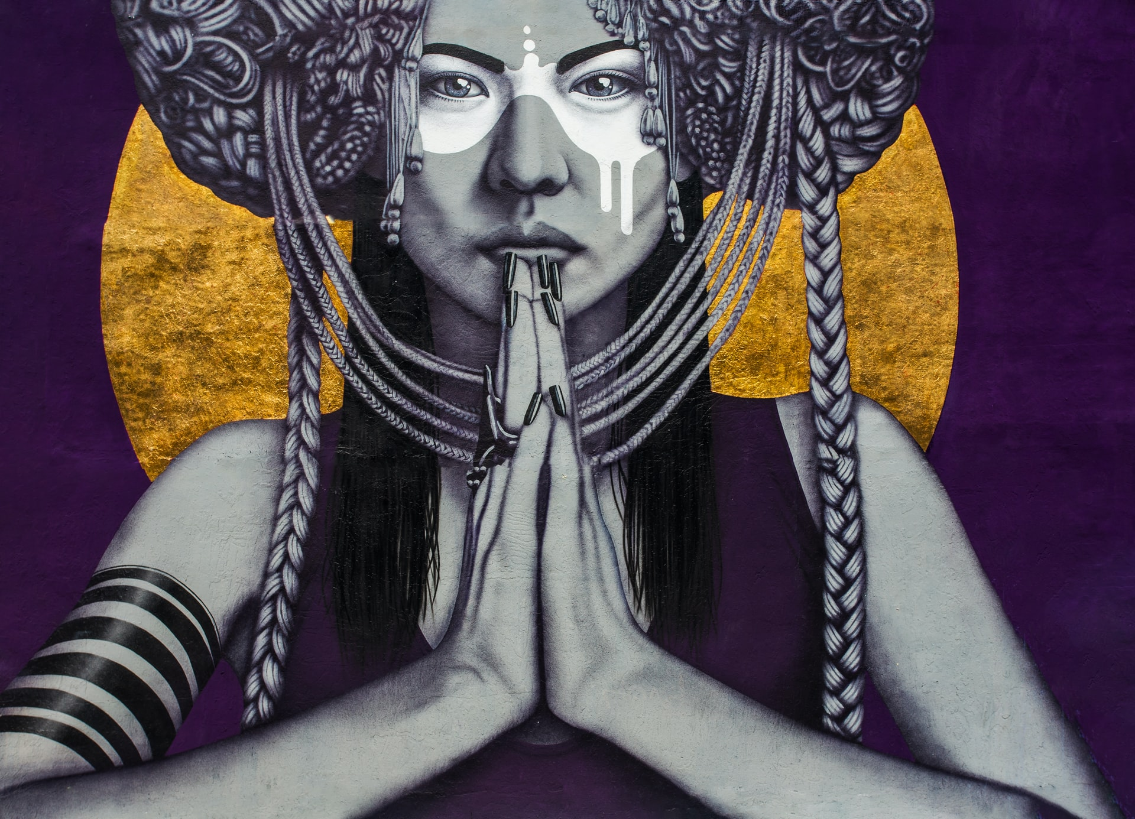
7 - The Evaluation

Your Journey to connect believe in your Power

In the box, write a summary of all that you have been through and send it to jovi@love2meditate.com. We will provide you with our observations, support and offer ideas for further development.
Remember, you have opened up the spiritual doors and connected with your Power, things will continue to unfold in the future. Enjoy and respect the person you are and please welcome in the changes.

