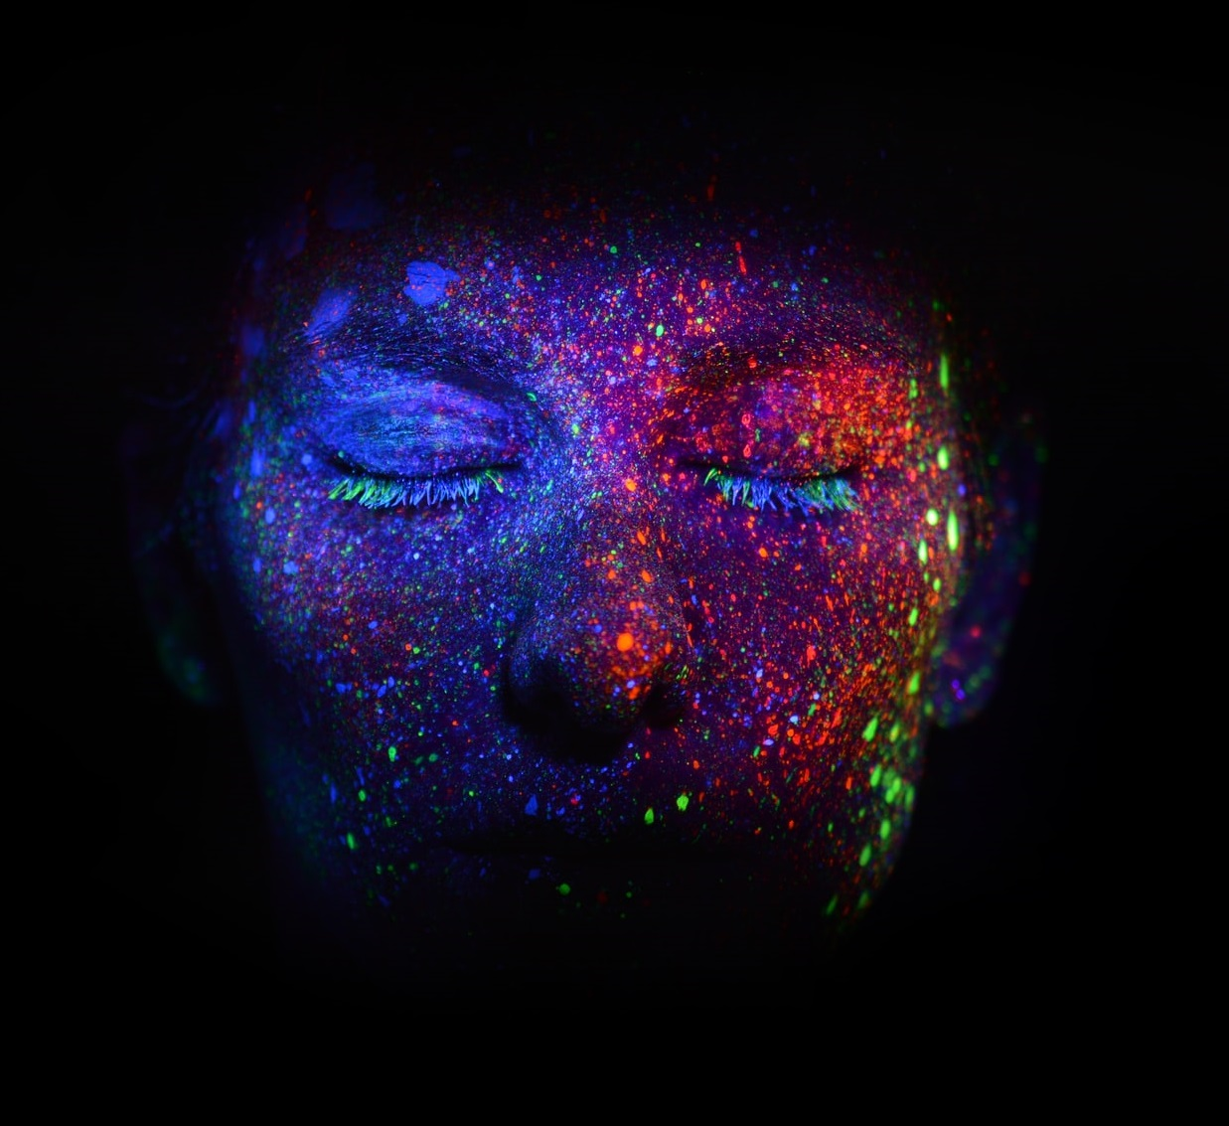

My Personal Journey

Write your name here
  - and the Date

Pure Divine Guidance | Jovi Hoonjan | Love 2 Meditate

Contents
1 - Introduction 2
2 – Spiritual Soul Uplift 3
3 - Back down to Earth 6
4 – Raising the Vibes 8
4 - Leap into the Future Ritual 11
7 – Abundant I am 16
8 - The Evaluation 19

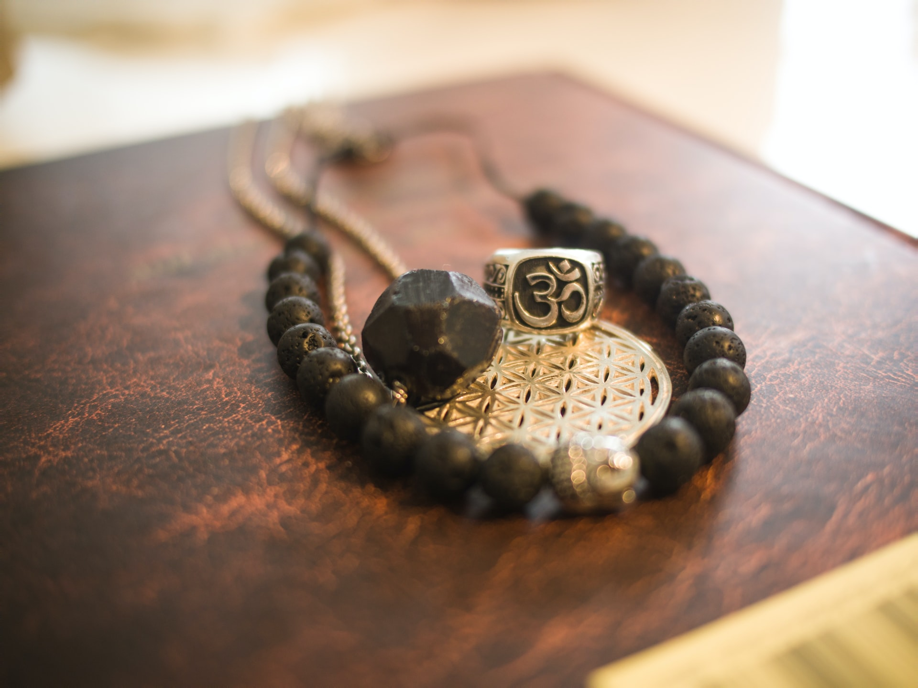
1 - Introduction

Please use this Journal to record all your insights and discoveries. Type in the boxes, they will automatically expand.
If you prefer to work with a printed copy, you will first need to expand the text boxes or remove them completely, creating space for you to write underneath the questions.

Feel free to listen to any of the meditations or repeat the exercises more than once – the more you do them, the stronger the impact you will have.

2 – Spiritual Soul Uplift

Date | What time of day was the meditation done? | What happened and what messages did you receive (feelings, sensations, relaxed, energized, sounds, images, inner knowing, sensations, warm, cold, tingling…)

In general, how did you like the Crystal Cave Spirits meditation?
If you feel you didn’t connect to the meditation, listen to the meditation again. Normally when you feel a dislike in something, it means that you need to have a break through to an understanding of it – a fear or stuck energy.

What happened to you in the cave? What do you remember?

What dreams did you have? Come back tomorrow to add your dreams here, did you sleep well?

Any further comments or insights?

3 - Back down to Earth

Today you did The Elements meditation, connecting you to the Bees, Earth, Water, Air and Fire elements.

Date | What time of day was the meditation done? | What happened and what messages did you receive (feelings, sensations, relaxed, energized, sounds, images, inner knowing, sensations, warm, cold, tingling…)

4 – Raising the Vibes

How did you get on today? Love raising vibrations, it brings in love, happiness, peace, gratitude and all nice things...

Date | What time of day was the meditation done? | What happened and what messages did you receive (feelings, sensations, relaxed, energized, sounds, images, inner knowing, sensations, warm, cold, tingling…)

Remember to come back tomorrow to record the dreams you had?

Any further comments or insights?

Before ‘leaping’ ahead to the ritual, how do you feel you are progressing so far?

Look back at the notes you have made, here and your journal. Do you see any repetitions in your comments? Do you feel you have made lots of similar discoveries? See if you can analyze them yourself. The more you can independently and confidently trust in your own interpretation, the stronger your intuition will become.

4 - Leap into the Future Ritual

Woohoo how was the leap?
Date | What time of day was the meditation done? | What happened and what messages did you receive (feelings, sensations, relaxed, energized, sounds, images, inner knowing, sensations, warm, cold, tingling…)

What were your overall thoughts on performing the ritual? Which animal did you connect with the most?

What insights came up for you?

Come back tomorrow to record your dreams.

Any further comments or insights? Do you think you will do this ritual again?

Rituals are amazing exercises to perform, we suggest you experiment and do more. You could create your very own ritual or you could change ours a little to suit you.
You could select different animals that you are personally drawn to and add them.

Really dive deep into making the connection within.

6. Cosmic Connection

How did the Cosmic Connection meditation go?
Date | What time of day was the meditation done? | What happened and what messages did you receive (feelings, sensations, relaxed, energized, sounds, images, inner knowing, sensations, warm, cold, tingling…)

What did you generally think about the meditation?

What insights and ‘a-ha’ moments came up for you?

Come back tomorrow to record your dreams.

Any further comments you would like to add?

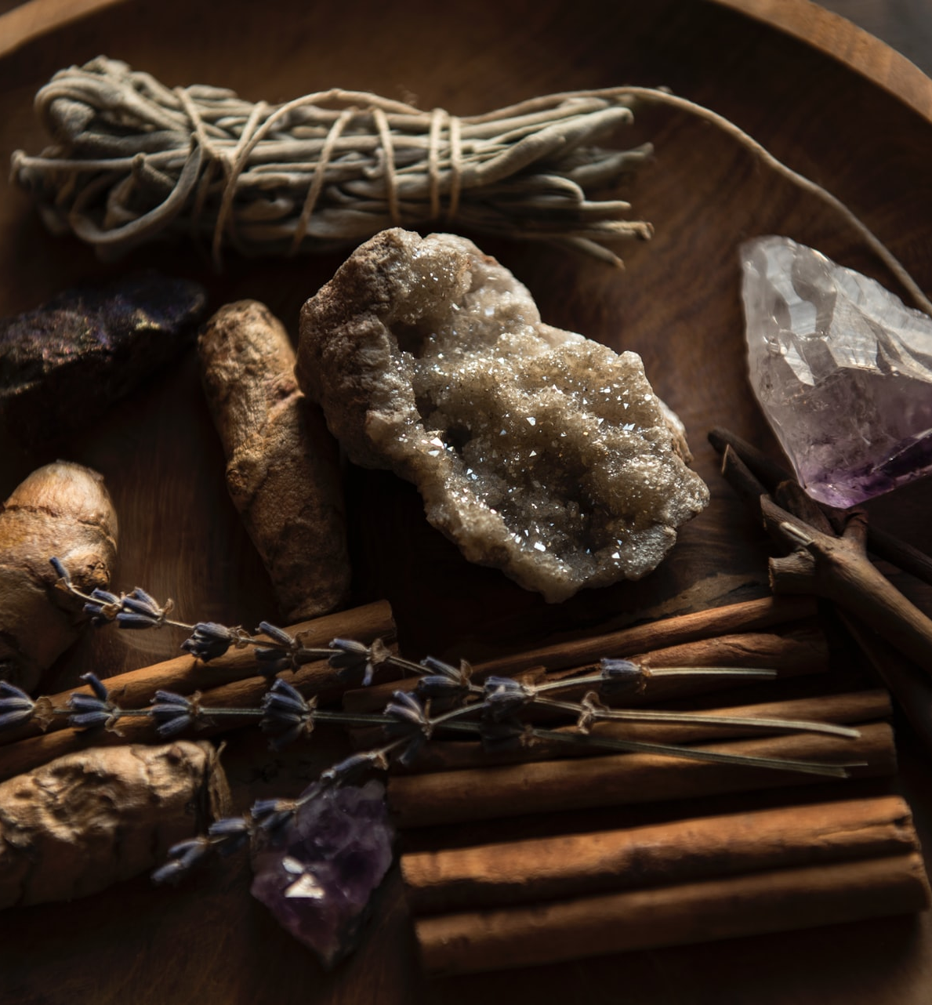
7 – Abundant I am

Manifest Abundance is the last meditation of the course. I hope you felt good listening to it…
Date | What time of day was the meditation done? | What happened and what messages did you receive (feelings, sensations, relaxed, energized, sounds, images, inner knowing, sensations, warm, cold, tingling…)

What did you think of this meditation?

What have you learned from this session?

Come back tomorrow to record your dreams.

Out of all the meditations you have done, which was your favourite and least favourite?

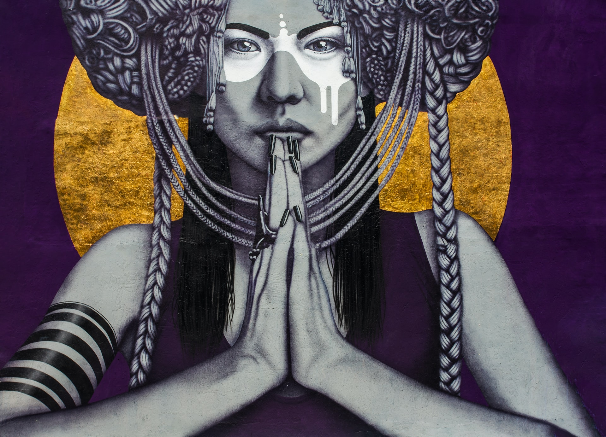
8 - The Evaluation

Your Journey to Pure Divine Connection

In the box, write a summary of all that you have been through and email it to jovi@love2meditate.com. We will provide you with our observations, support and offer ideas for further development.
You now have made powerful steps towards making pure divine connection. You have allowed guidance to flow within and help you to develop further spiritually. Enjoy and respect the person you are and welcome in the changes. I look forward to hearing all about your journey!

